Stephen LEMERCIER

Personal details
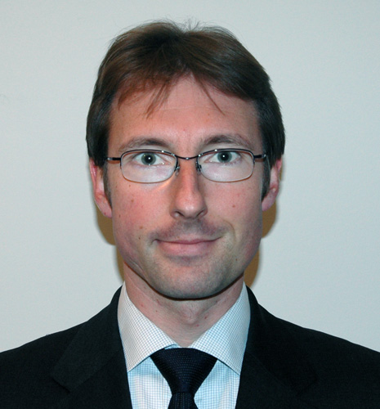
Postal address : 659 chemin des Soullières
06410 Biot, France
Telephone : +33 6 84 75 76 48
Email : stephen@lemercier.org
Age: 36
Marital status: married

Core skills
- Project Management
- System Integration
- Quality assurance
- Engineering processes
- Technical and planning expertise along with strong ability to deliver
- Vision bridging business need and technical solution

Employment history
2007-2010 – Amadeus (Sophia Antipolis, FR) – IT Consultant (Astek)
IT Consultant with focus on processes and industrialization of software delivery & code quality control.
Sep 2009 – now Amadeus – Process Management and Organization
Responsible for migration to CMMI Level2 of Configuration Management, quality assurance follow-up - Lifecycle review and adaptation; Process & tools improvements. Expert in Engineering lifecycle processes. Project Manager coaching and roll-out of procedures/practices from Amameth Methodology.

Mar 2007 – Sep 2009 Amadeus –Integration Manager for the e-Travel Management product
Responsible for the Software Integration phase (Code Delivery management and coordination, quality assurance, planning, process improvement), tools enhancements (operational predictability).

2004–2006 – Accenture (Sophia Antipolis, FR) – IT Project Manager
Project manager focusing on internet and component architectures, with a strong focus on emerging technologies such as RFID and e-paper.
May 2005 – Dec 2006 Louvre – Multimedia guide for Ingres exhibition (Paris)
Multimedia guide using the latest RFID technology for the Louvre, investigated interactive experimentations to complement the Museum’s mobility strategy.
Project management with technical, artistic and cultural staff, client follow-up, technology watch, managing third-parties across multiple locations (US, Europe), data analysis, setup and operations in highly sensitive environment, deployment across 130 units, team management (6 direct reports).

May 2004 – May 2005 Accenture Technology Labs - Research & Development projects (Sophia Antipolis)
- Created Accenture’s “White Paper & Point of View on Electronic Paper”
- Created solution of data analysis for remote patient monitoring (Team leader)
- Designed and build RFID prototypes focusing on retail, banking and pharmaceutical industries
- Participated in setting up and leading an RFID Bootcamp: internal training for senior executives to develop their market insight (hands on training + business potential).
- Business development with partners and prospects.

Jan 2004 – May 2004 Web Services Toolkit (Sophia Antipolis)
Management of the activities of design and build of a toolkit, providing in-depth coverage of web services implementations, in order to provide a better understanding of the technology (including security), and aimed at kick starting development efforts on such engagements.

1998–2003 – Andersen Consulting (Sophia Antipolis, FR) – System Engineer
Technical consultant for component architecture and web design.

Oct 2001 – Dec 2003 Societe Generale Investment Banking (Paris)
Designed, prototyped and built a high performance trading solution, to meet new expectations of a demanding market (traffic, functionality, ..)
Sep 2000 – Sep 2001 Nokia (Helsinki)
Designed and built technical services for the Common Internet Platform (logging, configuration, etc.), to be used by all Nokia B2B services.
Sep 1998 – Aug 2000 OneSwoop (Sophia Antipolis, London)
Designed and built a european-wide online car dealership, based on auction mechanism.

Within large migration projects, Stephen was responsible for:
- Designing and managing the coding of numerous banking functionalities,
- Managing operational migration to those new function,
- Coordinating project with 3rd party software company,
- Leading functional and stress testing,
- Coaching junior team members in his development team.

Educational history
1992 – 1997 – Productic Engineering degree / INSA Lyon (France)
1995 – 1996 – Industrial Engineering / Polytechnic School of Montréal (Canada – exchange year)
1992 – Baccalaureat C – special “Good” mention

Languages
English - fluent
German - academic knowledge

Technical skills
Languages Java, J2EE, .Net, SQL, HTML, XML, ASP, Web Services, SOAP, Axis
Tools WebLogic, Oracle, Afaria, Clearcase
Methods CMMI Model
Solutions RFID: SUN’s RFID solution, Savant architecture, EPC
Architectures Development, Execution and Operation architectures

Miscellaneous
Cinema, Photography, Acting (improvisation theatre), Travel (Canada, Thailand, Vietnam, Indonesia,…)

